NAME: Aquel Daley

LESSON: Introduction to SSRS Architecture

DATE: 9/2/2022

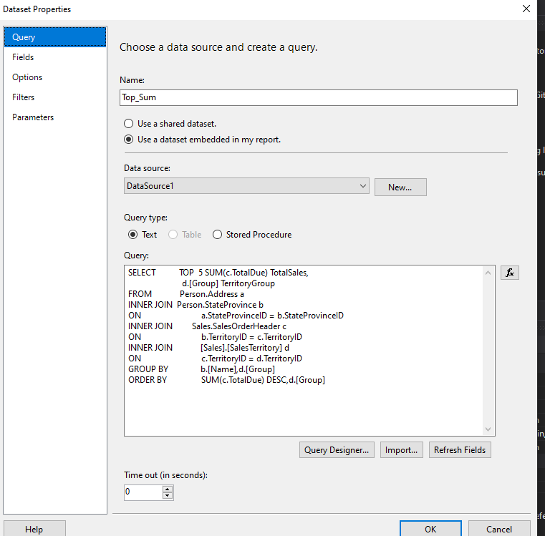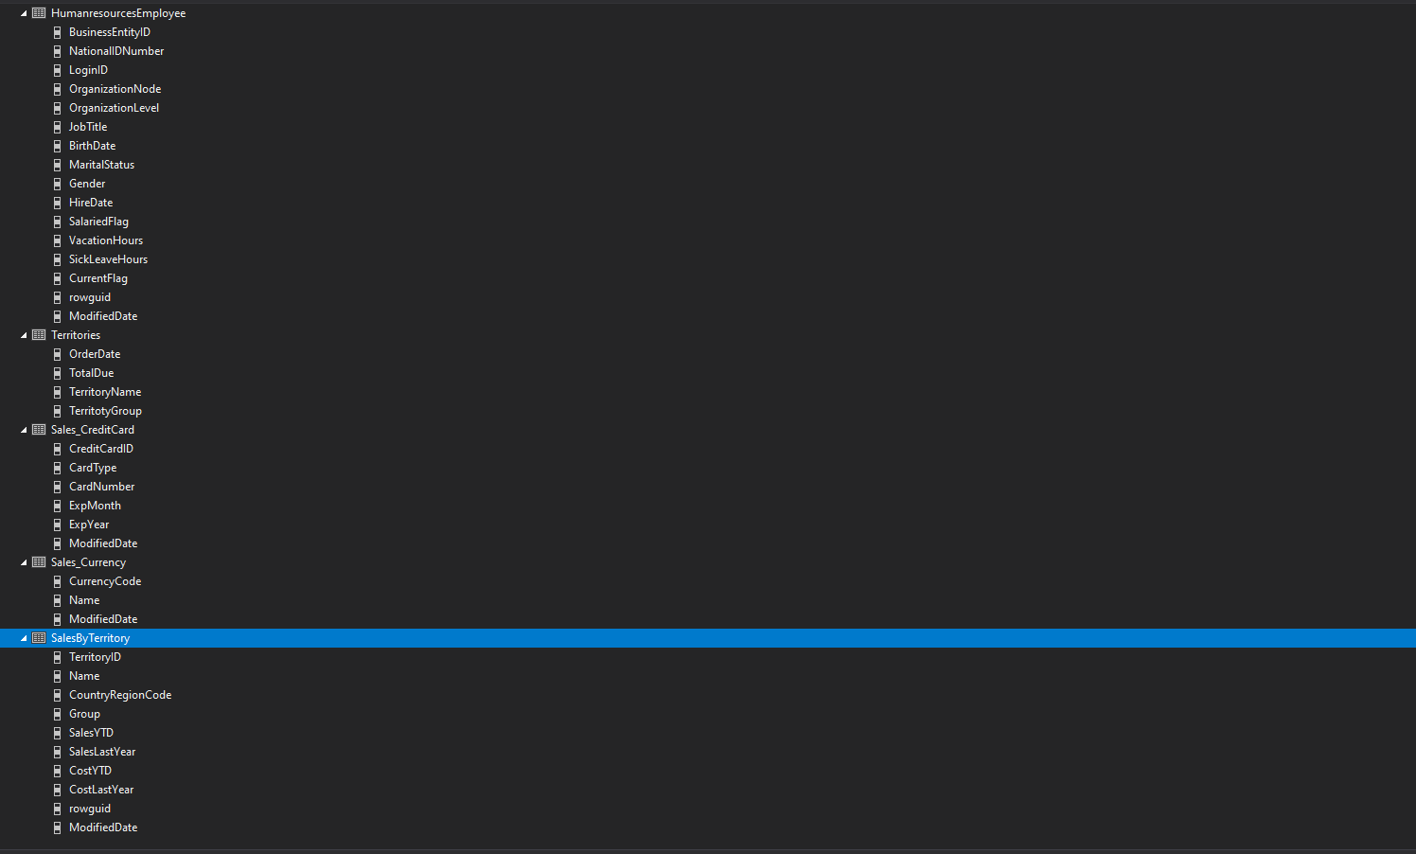

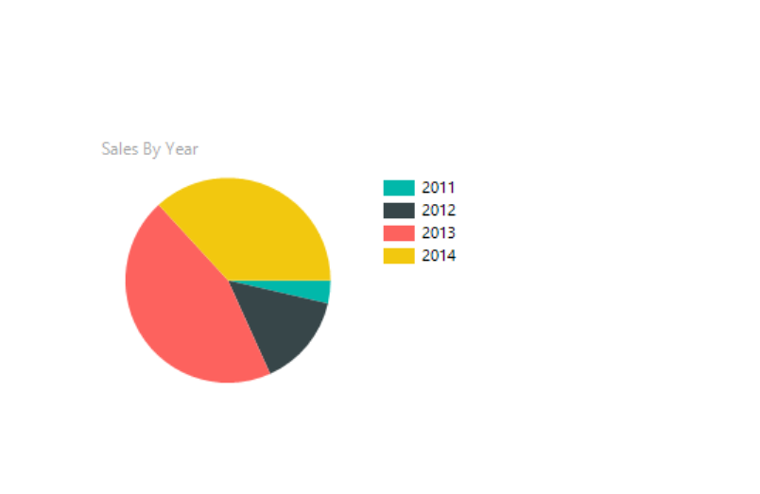

This is a pie chart, that represents sales by the year. The years are shown in different colors that differentiate each other.

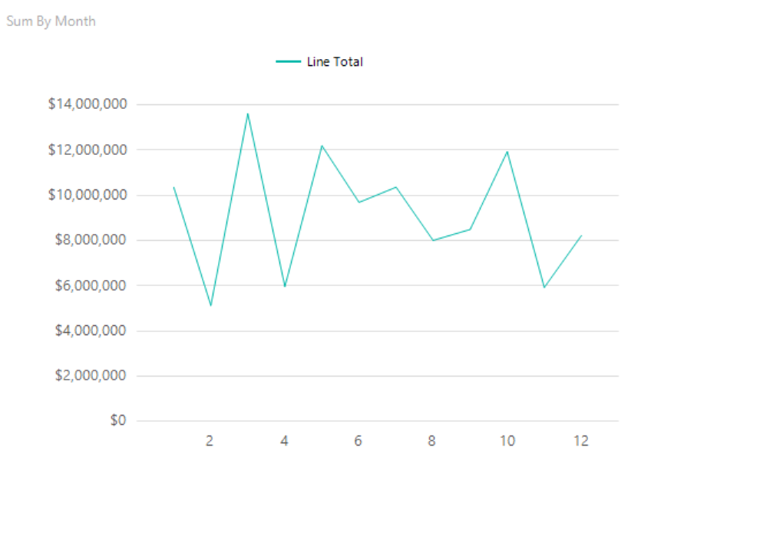

This is a line chart shows the sum of the revenue in months.

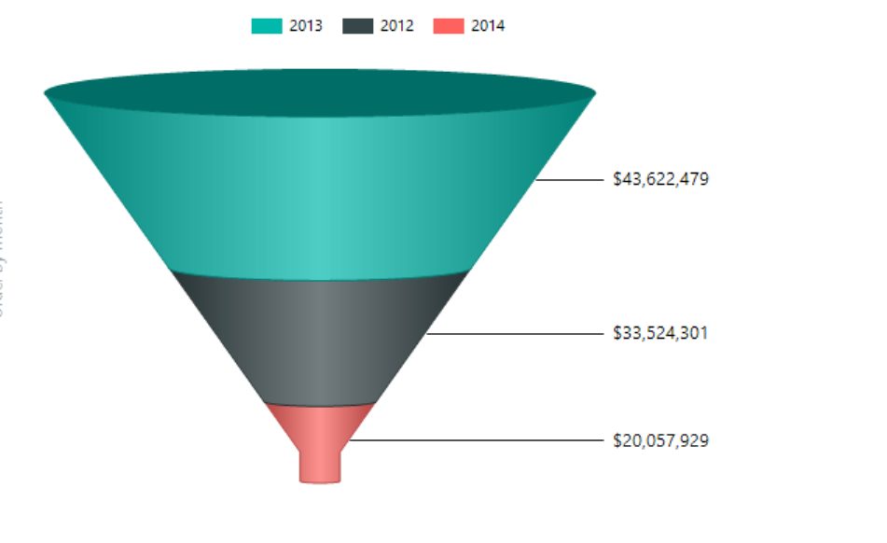

This is 3D funnel showing the showing the years in the revenue from lest to greatest.

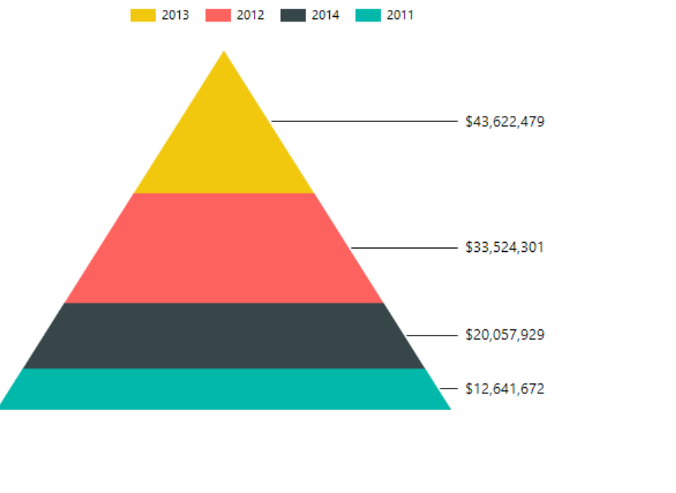

This is a pyramid chart showing the data of revenue from least to greatest from top to bottom.

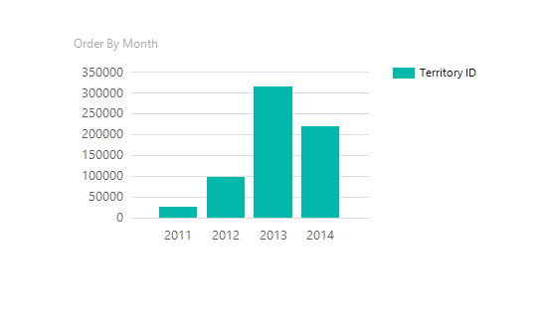

This is a column chart showing order by year and territoryID.

